To Compassion and Choices
From Andrew Schwartz and Chris Anderson
Date April 18, 2023
Subject Key findings from statewide Massachusetts poll

This document presents key findings from a statewide poll of 1,018 Massachusetts voters conducted March 13-21, 2023. Full methodological details are included at the end of this document.

Key Findings
Relatively few Massachusetts residents (just 16%) have heard about the legislative discussions about legalizing medical aid in dying. Yet after reading a brief description of what the bill would do—specifically, it would provide mentally sound, terminally ill adults the option to get a prescription for medication they could decide to take to die peacefully—nearly three-quarters of voters support legalization.

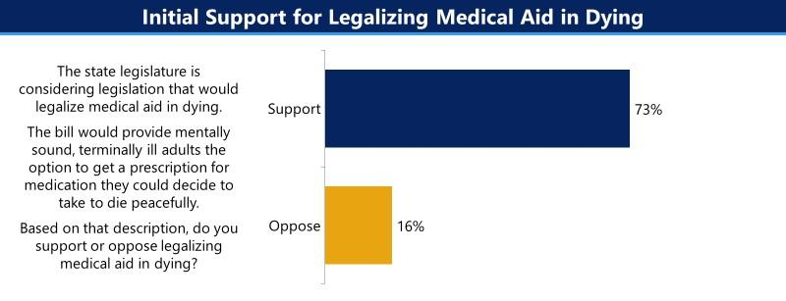

Sizable majorities of every demographic group favor legalization, including 76% of white voters, 63% of voters of color, 77% of those under age 45, and 74% of seniors. At least seven-in-ten voters in every region of the state support the bill, as do voters across the political spectrum: 79% of Democrats, 71% of unenrolled voters, and 68% of Republicans.

The measure has overwhelming support (89%) among Massachusetts voters who describe themselves as “strongly pro-choice”. Those who self-describe as “mostly pro-choice” also largely support the bill (68%), as does a plurality of self-described “pro-life” voters (47% support, 43% oppose).

More than two-thirds of Catholics (68%), Protestants (71%), and individuals living with a disability (68%) support the measure.

Voters react very favorably to specific aspects of the legislation, including:
- One safeguard is that a mental health professional must confirm that the individual is mentally sound (85% favorable)
- The law includes more than a dozen safeguards. One of those safeguards requires two doctors to confirm that the person is terminally ill and has less than six months to live (81% favorable)
- Terminally ill adults with six months or less to live would be able to ask their doctor for a prescription to peacefully end their suffering if it became unbearable (78% favorable)
- Doctor participation is voluntary, meaning no doctor would be forced to prescribe this medication against their will, even if an individual requests it and is eligible under the law (75% favorable)
- Individuals who take this medication must self-ingest or swallow it themselves—it is typically a powder they can mix with water or juice (74% favorable)
- Waiting periods are another safeguard. Specifically, the person must make two separate oral requests for the medication, with a 15-day waiting period between the two requests (71% favorable)
After hearing these facts about the law, support for legalization increases to 79%, with 15% opposed.

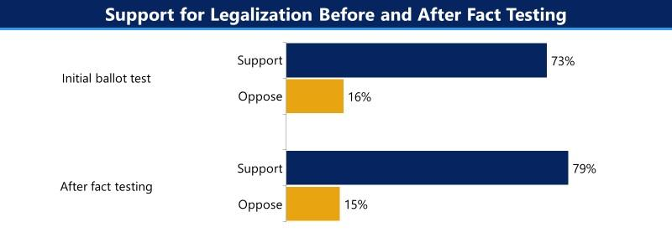

Support for legalization increases among almost every demographic group, with particular gains among independent/unenrolled voters (+7 points), those in households earning less than $100,000 per year (+7 points), Catholics (+8), and those living with disabilities (+10).

Methodology
This poll of 1,018 Massachusetts registered voters was commissioned by Compassion and Choices, a national organization dedicated to improving and expanding end-of-life care options.

The survey was conducted via online panel interviews between March 13 and 21, 2023. Respondents were screened to ensure they were registered to vote in Massachusetts. Slight weights were applied to ensure the data were representative of the age, gender, race/ethnicity, and education level of the Massachusetts electorate.

Beacon Research is a Boston-based firm specializing in providing highly accurate, actionable research to political and corporate clients. Beacon’s work as the Democratic partner on Fox News’ polling earned an A rating in 538’s pollster evaluations. Co-Founder Chris Anderson has provided polling to presidential campaigns, numerous ballot initiatives, state and local political candidates, and leading nonprofits in Massachusetts and across the country.

